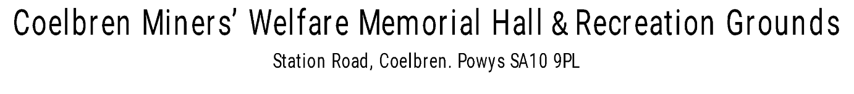

**Booking Request**

Contact Name/Organisation:

Contact address:

Contact Telephone Number:

Email Address:

Purpose of Hire (Event):

Date Required:

Time Required (Set Up):

Time Required (Main Event):

Total Number of Hours:

Rooms Required (delete* as necessary): Main Hall* Kitchen* Lounge Bar*

Music required:

Any Special Requirements:

__________________________________________________________________________________

**Current Charge for Hire:** Main Hall: £15.00 1st hour, £10 each hour thereafter

Lounge Bar: £10.00 per hour.

Kitchen available on request.

*Please note set up and clean up should be included in the total hire time

**Pay by Cash:** The hall’s bar is open every Friday between 7pm and 11pm. You are welcome to pay for your hire by cash at the bar.

**Pay by Card:** The hall’s bar is open every Friday between 7pm and 11pm. You are welcome to pay for your hire by card at the bar or alternatively we can send a payment link to the mobile number linked to the booking.

**Pay by Bank Transfer:** Our account details are **Account Number: 01666832. Sort Code: 30-93-53**

**A non-refundable deposit of 10% of the total charge will secure the booking, with the remainder due at least 14 days prior to the event. We reserve the right to cancel the booking where full payment is not made by the due date.**

Payment terms for weekly or monthly block bookings by arrangement.

**Please note booking conditions overleaf and sign where indicated.**

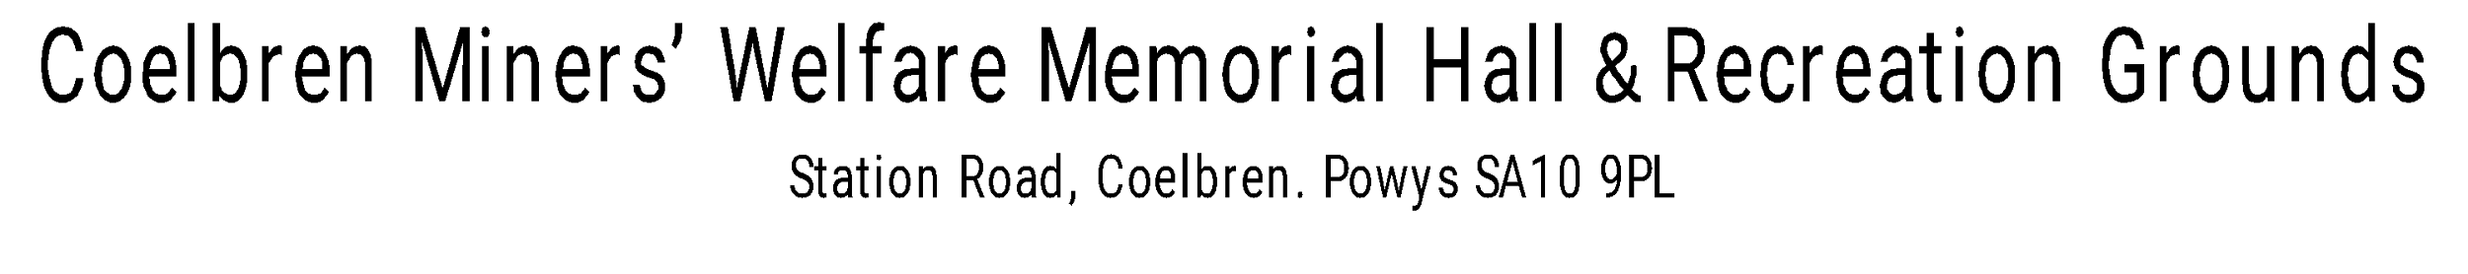

**Booking Conditions**

To ensure we comply with our licences and insurances, the following conditions MUST be adhered to. We thank you for your co-operation:

1. Smoking including E Cigarettes is strictly forbidden and unlawful inside the premises. Smoking areas can be found away from the

entrance to the building

1. The maximum number of persons at an event is 120 seated. The hall is licenced to hold 200 in total.
2. The hall is licensed to play music until Midnight
3. The hall is licenced to serve alcohol until 01:00 a.m.
4. No external electrical equipment to be used in the hall without prior notification. This allows us to check its suitability and that it has been tested
5. Decorations can be placed by the hirer, but it is asked that **only White-Tac** is used to secure to walls and that they are made of fire-retardant materials where applicable.
6. The hall will be cleaned prior to your event. It is expected that the hall is left in the same condition afterwards.
7. If there are any breakages, please inform a member of the committee or attending staff immediately.
8. Please make provision to take away any non-recyclable waste/rubbish from your event as the hall has no facilities to dispose of this. Recycling bins are available outside and to the left of the building.

**COVID REGULATIONS AS OF THE DATE OF THE EVENT HAVE T0 BE ADHERED TO.**

**Please note: Any damage to, or rubbish left at the hall, may incur an additional charge. Please help us keep our village facility in a condition fit for everyone’s use.**

_______________________________________________________________________________________

I/We agree with the conditions set out by Coelbren Miners’ Welfare Hall.

Signed (HIRER): * Date:

*By inserting your name above and returning electronically, for the purpose of the contract, it will be deemed to be your signature.

.________________________________________________________________________________________

This form can be returned electronically or printed and posted to the hall. Please place in an envelope clearly marked as “Booking Request”.

Thank you for your enquiry and we look forward to preparing for your event.

For further information please email us at: booking.cmwh@gmail.com